Ring
# Source: AI Source: Provided by: [Data Path: Persons Table -> ID Column: 1, Name_En Column: Motasem Essam] -> From: [ChatGPT] on [7/25/2026]
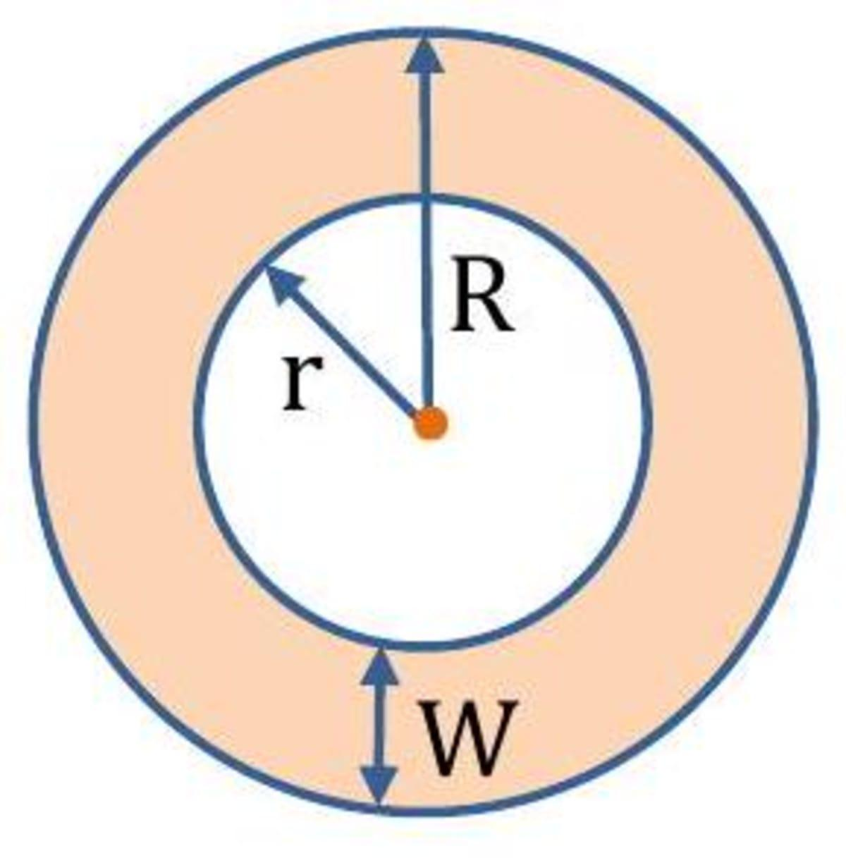
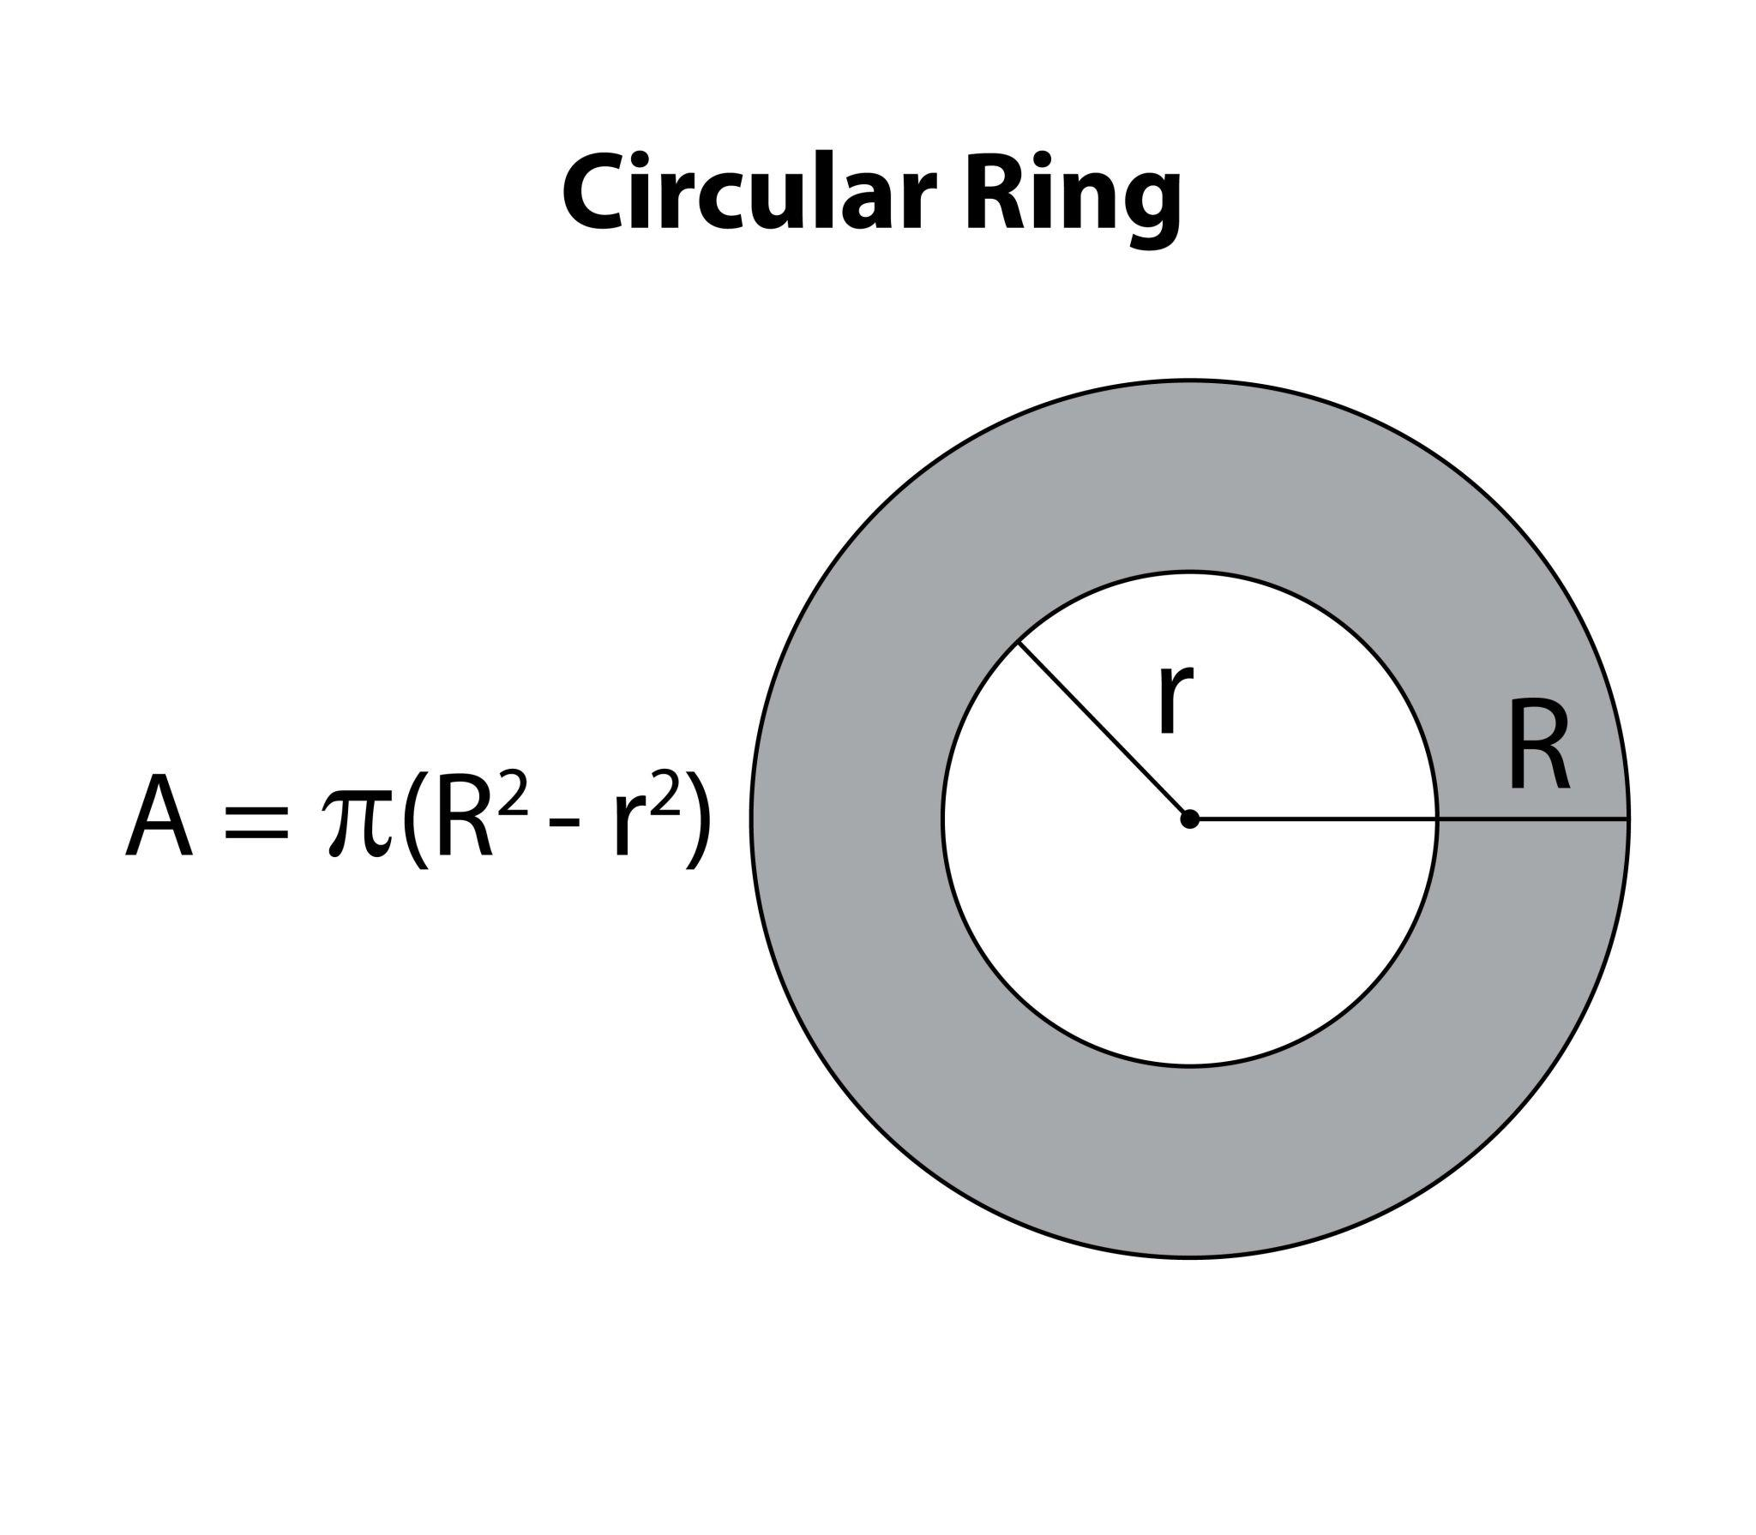
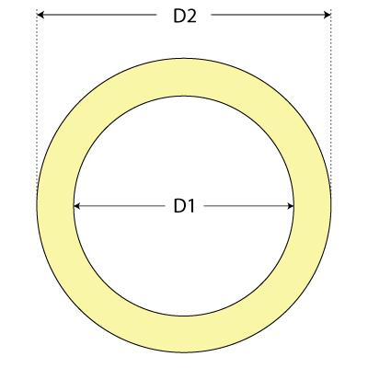
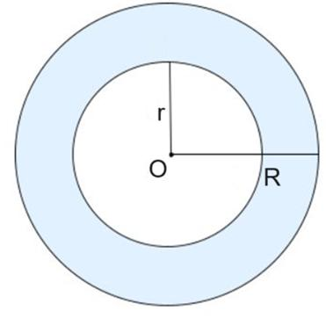

Definition
# Source: AI Source: Provided by: [Data Path: Persons Table -> ID Column: 1, Name_En Column: Motasem Essam] -> From: [ChatGPT] on [7/25/2026]
A Ring is a two-dimensional region surrounding a central area, typically bounded by an outer closed curve and an inner closed curve.
In elementary Euclidean geometry, the most common type of ring is a circular ring, also called an Annulus, formed by two concentric circles.
Ring = Region between an outer boundary and an inner boundary.
For a circular ring:
- Outer radius = $R$
- Inner radius = $r$
- $R>r>0$
- Common center = $O$

Fundamental Concept
# Source: AI Source: Provided by: [Data Path: Persons Table -> ID Column: 1, Name_En Column: Motasem Essam] -> From: [ChatGPT] on [7/25/2026]
A circular ring can be constructed by removing a smaller disk from a larger disk with the same center:
$$\boxed{\text{Ring}=\text{Outer Disk}-\text{Inner Disk}}$$
The resulting region contains all points whose distance from the common center is between $r$and $R$.
$$\boxed{r≤OP≤R}$$
For an open-boundary version, the inequalities can be adjusted depending on whether the boundaries are included.

Basic Structure
# Source: AI Source: Provided by: [Data Path: Persons Table -> ID Column: 1, Name_En Column: Motasem Essam] -> From: [ChatGPT] on [7/25/2026]
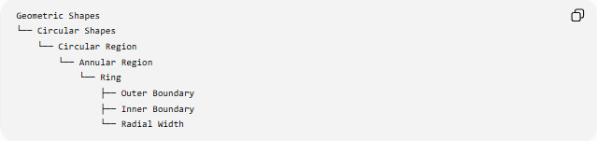
Geometric Shapes
└── Circular Shapes
└── Circular Region
└── Annular Region
└── Ring
├── Outer Boundary
├── Inner Boundary
└── Radial Width
For a circular ring:
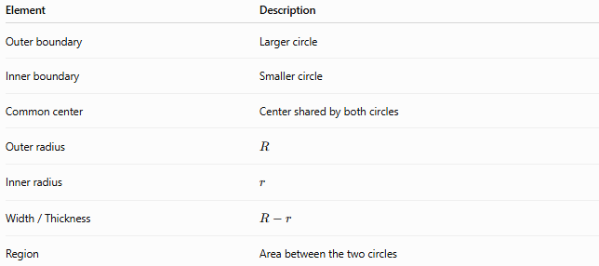
Element | Description
Outer boundary | Larger circle
Inner boundary | Smaller circle
Common center | Center shared by both circles
Outer radius | $$R$$
Inner radius | $$r$$
Width / Thickness | $$R-r$$
Region | Area between the two circles

Mathematical Representation
# Source: AI Source: Provided by: [Data Path: Persons Table -> ID Column: 1, Name_En Column: Motasem Essam] -> From: [ChatGPT] on [7/25/2026]
Let the common center be
$$O=\left(h , k\right)$$
The outer boundary is
$${\left(x-h\right)}^{2}+{\left(y-k\right)}^{2}=R^{2}$$
The inner boundary is
$${\left(x-h\right)}^{2}+{\left(y-k\right)}^{2}=r^{2}$$
Therefore, the circular ring is represented by
$$\boxed{r^{2}≤{\left(x-h\right)}^{2}+{\left(y-k\right)}^{2}≤R^{2}}$$
where
$$R>r>0$$

Main Formulas
# Source: AI Source: Provided by: [Data Path: Persons Table -> ID Column: 1, Name_En Column: Motasem Essam] -> From: [ChatGPT] on [7/25/2026]
Area
The ring's area is the area of the outer disk minus the area of the inner disk:
$$A=πR^{2}-πr^{2}$$
Therefore,
$$\boxed{A=π\left(R^{2}-r^{2}\right)}$$
Width / Thickness
$$\boxed{t=R-r}$$
Outer Circumference
$$\boxed{C_{o}=2πR}$$
Inner Circumference
$$\boxed{C_{i}=2πr}$$
Total Boundary Length
If both boundaries are counted:
$$P=C_{o}+C_{i} \\ \boxed{P=2π\left(R+r\right)}$$

Alternative Area Formula
# Source: AI Source: Provided by: [Data Path: Persons Table -> ID Column: 1, Name_En Column: Motasem Essam] -> From: [ChatGPT] on [7/25/2026]
Since
$$R^{2}-r^{2}=\left(R-r\right)\left(R+r\right)$$
the area can also be written as
$$\boxed{A=π\left(R-r\right)\left(R+r\right)}$$
Using the thickness $t=R-r$:
$$\boxed{A=πt\left(R+r\right)}$$
If the mean radius is
$$ρ=\frac{R+r}{2}$$
then
$$\boxed{A=2πρt}$$

Types of Rings

1-Circular Ring
# Source: AI Source: Provided by: [Data Path: Persons Table -> ID Column: 1, Name_En Column: Motasem Essam] -> From: [ChatGPT] on [7/25/2026]
The standard ring formed between two concentric circles.
$$\boxed{A=π\left(R^{2}-r^{2}\right)}$$

2-Thin Ring
# Source: AI Source: Provided by: [Data Path: Persons Table -> ID Column: 1, Name_En Column: Motasem Essam] -> From: [ChatGPT] on [7/25/2026]
A ring whose thickness is small relative to its radius.
$$R-r≪R$$
The exact area remains
$$A=π\left(R^{2}-r^{2}\right)$$
For a sufficiently thin ring, an approximation is
$$\boxed{A≈2πRt}$$

3-Thick Ring
# Source: AI Source: Provided by: [Data Path: Persons Table -> ID Column: 1, Name_En Column: Motasem Essam] -> From: [ChatGPT] on [7/25/2026]
A ring whose radial thickness is relatively large compared with its radius.
$$t=R-r$$
There is no universal numerical threshold separating a thin ring from a thick ring. These are descriptive terms.

4-Equal-Width Ring
# Source: AI Source: Provided by: [Data Path: Persons Table -> ID Column: 1, Name_En Column: Motasem Essam] -> From: [ChatGPT] on [7/25/2026]
A ring with a constant radial width.
For concentric circular boundaries, this is automatically true:
$$\boxed{t=R-r}$$
The width is the same in every radial direction.

5-Multiple Concentric Rings
# Source: AI Source: Provided by: [Data Path: Persons Table -> ID Column: 1, Name_En Column: Motasem Essam] -> From: [ChatGPT] on [7/25/2026]
Several rings arranged around the same center.
If the radii are
$$r_{1}<r_{2}<r_{3}<⋯<r_{n}$$
then each adjacent pair forms a ring:
$$A_{i}=π\left(r_{i+1}^{2}-r_{i}^{2}\right)$$
There are
$$\boxed{n-1}$$
rings between $n$concentric circles.

Ring vs Annulus
# Source: AI Source: Provided by: [Data Path: Persons Table -> ID Column: 1, Name_En Column: Motasem Essam] -> From: [ChatGPT] on [7/25/2026]
In geometry, ring is a broader and more informal term, while annulus is the precise standard term for the region between two concentric circles.
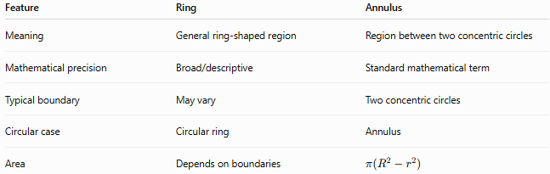
Feature | Ring | Annulus
Meaning | General ring-shaped region | Region between two concentric circles
Mathematical precision | Broad/descriptive | Standard mathematical term
Typical boundary | May vary | Two concentric circles
Circular case | Circular ring | Annulus
Area | Depends on boundaries | $$π\left(R^{2}-r^{2}\right)$$
Thus:
$$\boxed{\text{Circular Ring}=\text{Annulus}}$$
in the usual geometric context.

Ring vs Circle
# Source: AI Source: Provided by: [Data Path: Persons Table -> ID Column: 1, Name_En Column: Motasem Essam] -> From: [ChatGPT] on [7/25/2026]
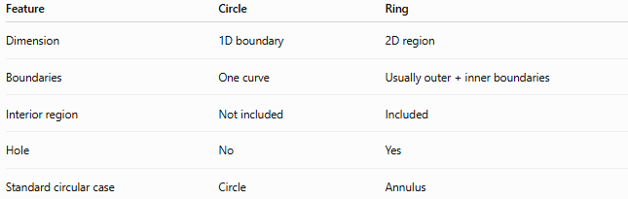
Feature | Circle | Ring
Dimension | 1D boundary | 2D region
Boundaries | One curve | Usually outer + inner boundaries
Interior region | Not included | Included
Hole | No | Yes
Standard circular case | Circle | Annulus
A circle is a boundary, whereas a ring is a region.

Ring vs Disk
# Source: AI Source: Provided by: [Data Path: Persons Table -> ID Column: 1, Name_En Column: Motasem Essam] -> From: [ChatGPT] on [7/25/2026]
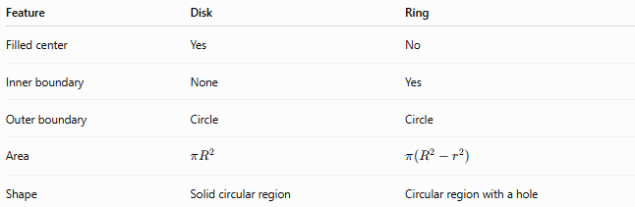
Feature | Disk | Ring
Filled center | Yes | No
Inner boundary | None | Yes
Outer boundary | Circle | Circle
Area | $$πR^{2}$$ | $$π\left(R^{2}-r^{2}\right)$$
Shape | Solid circular region | Circular region with a hole
Conceptually:
$$\boxed{\text{Disk}-\text{Inner Disk}=\text{Ring}}$$

Symmetry
# Source: AI Source: Provided by: [Data Path: Persons Table -> ID Column: 1, Name_En Column: Motasem Essam] -> From: [ChatGPT] on [7/25/2026]
A circular ring has the same symmetries as concentric circles.
Reflection Symmetry
Every line passing through the common center is an axis of symmetry.
Therefore, it has infinitely many reflection axes.
Rotational Symmetry
A circular ring remains unchanged under any rotation about its center.
Thus, it has continuous rotational symmetry.
Point Symmetry
A circular ring also has symmetry under a ${180}^{∘}$rotation about its center.

Polar Representation
# Source: AI Source: Provided by: [Data Path: Persons Table -> ID Column: 1, Name_En Column: Motasem Essam] -> From: [ChatGPT] on [7/25/2026]
For a ring centered at the origin:
$$\boxed{r≤ρ≤R}$$
with
$$0≤θ<2π$$
Its area can be calculated using polar coordinates:
$$A=\int_{0}^{2π}{\int_{r}^{R}{ρ}} dρ dθ$$
which gives
$$\boxed{A=π\left(R^{2}-r^{2}\right)}$$

Example
# Source: AI Source: Provided by: [Data Path: Persons Table -> ID Column: 1, Name_En Column: Motasem Essam] -> From: [ChatGPT] on [7/25/2026]
Suppose a ring has:
$$R=10$$
and
$$r=6$$
Thickness
$$t=10-6=4$$
Area
$$A=π\left({10}^{2}-6^{2}\right) \\ A=π\left(100-36\right) \\ \boxed{A=64π}$$
Outer circumference
$$C_{o}=20π$$
Inner circumference
$$C_{i}=12π$$
Total boundary length
$$P=20π+12π \\ \boxed{P=32π}$$

Classification Summary
# Source: AI Source: Provided by: [Data Path: Persons Table -> ID Column: 1, Name_En Column: Motasem Essam] -> From: [ChatGPT] on [7/25/2026]
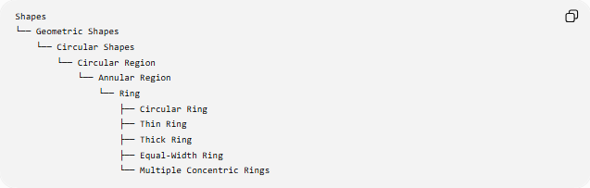
Shapes
└── Geometric Shapes
└── Circular Shapes
└── Circular Region
└── Annular Region
└── Ring
├── Circular Ring
├── Thin Ring
├── Thick Ring
├── Equal-Width Ring
└── Multiple Concentric Rings

Important terminology
# Source: AI Source: Provided by: [Data Path: Persons Table -> ID Column: 1, Name_En Column: Motasem Essam] -> From: [ChatGPT] on [7/25/2026]
- Ring — broad/descriptive term for a ring-shaped region.
- Circular Ring — ring bounded by circular boundaries.
- Annulus — standard mathematical term for the region between two concentric circles.
- Thin Ring and Thick Ring — descriptive classifications, not universally standardized mathematical categories.
- Equal-Width Ring — descriptive; for an ordinary annulus, radial width is already constant.

Key Points
# Source: AI Source: Provided by: [Data Path: Persons Table -> ID Column: 1, Name_En Column: Motasem Essam] -> From: [ChatGPT] on [7/25/2026]
- A ring is a 2D region, not merely a boundary.
- A circular ring is the region between two concentric circles.
- Its standard mathematical name is annulus.
- The outer radius is $R$, and the inner radius is $r$.
- Thickness:
$$\boxed{t=R-r}$$
- Area:
$$\boxed{A=π\left(R^{2}-r^{2}\right)}$$
- Total boundary length:
$$\boxed{P=2π\left(R+r\right)}$$
- A ring has an inner hole.
- A circular ring has infinitely many reflection axes and continuous rotational symmetry.
- Multiple concentric circles can create multiple rings.

Conclusion
# Source: AI Source: Provided by: [Data Path: Persons Table -> ID Column: 1, Name_En Column: Motasem Essam] -> From: [ChatGPT] on [7/25/2026]
A Ring is a region surrounding a central opening. In standard Euclidean geometry, the circular form is the Annulus, obtained by removing a smaller concentric disk from a larger disk. Its most important geometric quantities are its outer radius, inner radius, thickness, area, and boundary lengths.

